Feminism and the Kurdish Freedom Movement
Dilar Dirik
This article is an edited version of a presentation at the “Dissecting Capitalist Modernity–Building Democratic Confederalism” Conference at Hamburg University, April 3-5th, 2015.

The fact that we are discussing the Kurdish freedom movement’s approaches, ideas, and re-conceptualizations of freedom today at this conference with people from so many diverse backgrounds is quite telling of the larger impacts of the Kobanê resistance, which go far beyond its military aspects.

The World Women’s March this year was launched at the border between North (Bakur) and West Kurdistan (Rojava), the artificial line which separates the twin cities Qamişlo and Nisêbin from each other. The committee took this decision in order to pay tribute to the resistance of the Women’s Defense Units YPJ in Kobanê against the Islamic State (ISIS). This, among many other examples, illustrates the increasing interest of feminists around the world in the Kurdish women’s movement.
So, at this crucial period in which Kurdish women contributed to a re-articulation of women’s liberation by rejecting to comply with the premises of the global patriarchal capitalist nation-state order, by breaking the taboo of women’s militancy (which is a taboo everywhere in the world, as it breaks social boundaries), by reclaiming legitimate self-defense, by dissociating the monopoly of power from the state, and by fighting a brutal force not on behalf of imperialist forces, but in order to create their own terms of liberation, not only from the state or fascist organizations, but also their own community, what can feminist movements learn from the experience of Kurdish women?
First, it should be mentioned that Kurdish women’s relationship to the feminisms in the region has often been quite complicated. Turkish feminists for instance had the tendency to marginalize Kurdish women, which they perceived as backward, and tried to forcefully assimilate them into their nationalist “modernization project”. In practice, this meant that all women first had to be “Turkish” in order to qualify for liberation. Their political struggle, especially when armed, was often met with harsh state violence, which used a gross combination of racism and sexism, centered around sexualized torture, systematic rape, and propaganda campaigns that portrayed militant women as prostitutes, because they dared to pose themselves as enemies of hyper-masculine armies. In the Western discourse, Kurdish women’s agency in their struggle was often denied by claims that they are “being instrumentalized for the national cause” or that they participate in the liberation struggle in order to escape their sad lives as “victims of a backward culture”. Apart from being inherently chauvinistic and sexist, these kinds of arguments are further unable to explain the fact that the Kurdish movement created a popular grassroots feminist movement which challenged tradition and transformed society to a striking extent. Today, when we look at how the mainstream treats the Kurdish women’s resistance against ISIS, we can see very simplistic and problematic approaches that focus on the war in terms of a physical military fight only, even a certain Schadenfreude that ISIS is being defeated by women, a classical “girls beat boys” type of attitude. The women’s political motivations, their ideologies are ignored or co-opted within this context, even by feminists. Not many investigate the ideals that drive their struggle, barely anyone questions the fact that the ideology with which the women are fighting against ISIS is in fact on the terrorist list of many Western countries.

The aim of this talk is not to imply that feminism and the Kurdish women’s movement are two separate things. Rather, I want to investigate their relationships and focus on the original approaches of the Kurdish women’s movement that could provide some perspectives for other movements.
Of course there is not one singular feminism, but several strands which sometimes differ greatly from each other. The specifics of the experience of Kurdish women which created direct lived consciousness of the fact that different forms of oppression are inter-related, due to their multiply-oppressed position as members of a stateless nation in a world ruled by states, socio-economic exclusion, and patriarchal violence by the state and the community, as well as the Kurdish freedom movement’s critique of colonialism, capitalism, and the state, perhaps suggest anarchist, socialist and anti-colonial feminist movements to be the closest to the Kurdish women’s movement’s experience.
Yet, while claiming feminism as an important part of historical society and its legacy as a heritage, the discussions within the Kurdish women’s movement today aim to investigate the limits of feminism and move beyond it. This is not at all a classical post-feminist approach, nor does it reject feminism. Moving beyond means to systematize an alternative to the dominant system through a radical systemic critique and the communalization of the multi-front struggle, especially by politicizing the grassroots, leading a mental revolution, and transforming or figuratively killing the masculine and its multitudinous expressions, as well as questioning and resisting the entire global order, the stage of this violence and oppression. Kobanê, as well as the two other cantons of Rojava –Cizîre and Afrîn- are an example of the practical implementation of this. As I argue, the resistance of Kobanê, where courageous women defeated the most fascist forces of our day, has a lot to do with the people’s political ideology and envisioned model. The victory of Kobanê is a direct result of the social and political organization of the cantons, as well as the movement’s concept of freedom, far beyond nationalism, power, and the state.

Abdullah Öcalan, the ideological representative of the PKK, explicitly states that patriarchy, along with capitalism and the state lie at the roots of oppression, domination, and power and makes the connection between them clear: “All the power and state ideologies stem from sexist attitudes and behaviour[...]. Without women’s slavery none of the other types of slavery can exist let alone develop. Capitalism and nation-state denote the most institutionalized dominant male. More boldly and openly spoken: capitalism and nation-state are the monopolism of the despotic and exploitative male”. He further claims: “Nothing in the Middle East is as gruesome as the social status of the woman. The enslavement of the woman is similar to the enslavement of the peoples, except it is even older”. Elsewhere: “The project of women’s liberation goes far beyond the equality of the sexes, but moreover describes the essence of general democracy, of human rights, of harmony with nature and communal equality” (Öcalan, 2010, 203).
The Kurdish freedom movement’s outlook on women’s liberation is of an explicit communalist nature. Rather than deconstructing gender roles to infinity, it treats the conditions behind current concepts of womanhood as sociological phenomena and aims to redefine such concepts by formulating a new social contract. It criticizes mainstream feminism’s common analysis of sexism in terms of gender only, as well as its failure to achieve wider social change and justice by limiting the struggle to the framework of the persisting order. One of feminism’s main tragedies is its falling into the trap of liberalism. Under the banner of liberation, extreme individualism and consumerism are often propagated as emancipation and empowerment, posing clear obstacles to any collective action or to even touch the issues of real people. Of course individual liberties are crucial to democracy, but failure to mobilize in a grassroots manner requires a fundamental self-critique of feminism. The feminist term “intersectionality” of course underlines that forms of oppression are interlinked and that feminism needs to take a holistic approach to tackle them. But often, the feminist circles that engage in these debates fail to touch the real lives of millions of affected women, generating yet another vacuumed discussion on radicalism, inaccessible to most. How radical or intersectional is a struggle that fails to spread?
These attitudes, according to the Kurdish women’s movement, are linked to the subscription to positivist science and the relationship between knowledge and power, which blurs the explicit links between forms of domination, thus eliminating the belief in a different world by portraying the global system as the natural, immutable order of things. Due to its specific socio-political and economic conditions, as well as a firm ideological stance, accompanied by much sacrifice, the Kurdish women’s movement was able to mobilize into a mass movement by arriving at certain conclusions not just through theoretical debates, but actual lived experiences and practices, which not only created direct political consciousness but also an attachment to collectively find solutions, against all odds.
Thus, encouraged by Öcalan’s suggestion to develop a scientific method that challenges the hegemonic understanding of the sciences, especially the social sciences, which reproduce mechanisms of violence, exclusion, and oppression -one that does not limit itself to categorizing phenomena around humans and community without considering the fact that these are alive and potentially able to solve their problems, and that split areas of life from each other by creating myriads of scientific branches, but instead proposes a science that practically seeks to provide solutions to social problems, a “sociology of freedom”, centered around the voices and experiences of the oppressed- the women’s movement has been engaging in theoretical debates and proposed the concept of “jineology” (jin, Kurdish: “woman”). Discussions and debates are held in the Qandil mountains, at the frontlines in Rojava, as well as in poor neighborhoods in Diyarbakir – every street corner can be turned into an academy. Questions like “How to re-read and re-write women’s history? How is knowledge attained? What methods can be used in a liberationist quest for truth, when today’s science and knowledge productions take knowledge away from us and serve to maintain the status quo?” arise in intensive discussions. The deconstruction of patriarchy and other forms of subjugation, domination, and violence are accompanied by discussions on the construction of alternatives based on liberationist values and solutions to freedom issues.
While defining itself as a women’s science or women’s quest for knowledge itself, an objection that jineology poses to feminism is that it often occupies itself with analyzing social issues merely through gender lenses. While deconstructing gender roles and patriarchy has immensely contributed to our understanding of sexism and other forms of violence and oppression, this has not always successfully proposed what kind of alternative we can collectively create instead. If concepts such as man and woman, no matter how socially constructed they may be, look like they will persist in the minds of people for a while, should we perhaps try to set new terms of existence, provide them with a liberationist essence in the attempt to overcome them? Let us not forget the background behind which these discussions are being held – in and around ultra-conservative societies with limited room for individual self-expression that deem women as unworthy, voiceless servants of men, a context of normalized, overtly institutionalized violence against women. If it is possible to re-imagine concepts of identity such as the “nation” by disassociating it from ethnic implications and aiming at forming a unity based on principles, in other words, a unity of thought, consisting of political subjects rather than objects serving the state (which is the idea that is advocated in multi-cultural Rojava, the “democratic nation” as articulated by Öcalan), can we also create a new free, radically empowering women’s identity, based on autonomy and freedom to shape a new sense of community, free from hierarchy and domination? Jineology does not aim to perpetuate an essentialist concept of womanhood, a new assigning of a social role with limited room for movement, neither does it regard itself as a provider of answers, but proposes itself as a method to explore such arising questions in a collectivist manner. By researching history and history writing, jineology tries to learn from ruptures in mythologies and religions, understand the communalist forms of organization in the Neolithic age and beyond, investigate the relationships between means of production and social organization, and the rise of patriarchy with the emergence of accumulation and property.
And yet, while criticizing feminism’s fixation on gender, the Kurdish women’s movement at the same time, due to its own experience, recognizes the urgent need to pay attention to specific oppressions. In fact, the core element of this movement’s organizational structure is the autonomous self-organization of groups and communities in order to enhance radical democracy. Unlike most leaders of classical national liberation movements, Öcalan emphasizes the need for autonomous and conscious feminist struggle and even prioritizes women’s liberation: “The twenty first century must be the era of awakening; the era of the liberated, emancipated woman [...]. I believe [women’s liberation] should have priority over the liberation of homelands and labour” (Öcalan, 2013, p.59). There are plenty of examples of how the Kurdish women’s movement tries to live this autonomy in practice here and now, rather than projecting it to a time in the future – even one brief look at Kurdish women’s participation and power in Turkey’s politics would speak volumes. Women’s liberation is not just seen as an aim, but as a method that needs to be practiced on an everyday basis. It is not something that will be achieved in a democracy, but it is democracy in practice.
Today, the movement splits power equally between one woman and one man from party presidencies to neighborhood councils through its co-chair principle. Beyond providing women and men with equal decision-making power, the co-chair concept aims to decentralize power, prevent monopolism, and promote consensus-finding. This again demonstrates the association of liberation with communalist decision-making. The women’s movement is autonomously organized, socially, politically, militarily. While these organizational principles seek to guarantee women representation, massive social and political mobilization raises society’s consciousness, which requires a radical mentality revolution, because hierarchy and domination first establish themselves in thought.
Inspired by these principles, the Rojava cantons enforce co-presidencies and quotas, and created women’s defense units, women’s communes, academies, tribunals, and cooperatives in the midst of war and under the weight of an embargo. The women’s movement Yekîtiya Star is autonomously organized in all walks of life, from defense to economy to education to health. Autonomous women’s councils exist parallel to the people’s councils and can veto the latter’s decisions. Men committing violence against women are not supposed to be part of the administration. Gender-based discrimination, forced marriages, domestic violence, honor killings, polygamy, child marriage, and bride price are criminalized. Many non-Kurdish women, especially Arabs and Assyrians, join the armed ranks and administration in Rojava and are encouraged to organize autonomously as well. In all spheres, including the internal security forces (asayish) and the People’s Defense Units YPG and Women’s Defense Units YPJ, gender equality is a central part of education and training. As Ruken, an activist of the women’s movement in Rojava said: “We don’t knock on people’s doors and tell them they are wrong. Instead, we try to explain to them that they can organize themselves and give them the means to determine their own lives”.
Interestingly, though women’s liberation was always part of the PKK’s ideology, the women’s autonomous organization emerged simultaneous to the general shift of the political aim from the nation-state towards local grassroots-democratic mobilization. As the relationship between different forms of oppression was identified, as the oppressive assumptions and mechanisms of the statist system were exposed, alternative solutions were sought, resulting in the articulation of women’s liberation as an uncompromising principle.
Rather than aspiring to quest for justice within state-granted concepts such as legal rights, which is one of the pre-occupations of mainstream feminism, the Kurdish women’s movement came to the conclusion that the road to liberation requires a fundamental critique of the system. Instead of putting the burden on women, women’s liberation becomes a matter of responsibility for all of society, because it becomes a measure for society’s ethics and freedom. For a meaningful freedom struggle, women's liberation must be an aim, but also an active method in the liberation process. In fact, expecting any meaningful social change from the very mechanisms that perpetuate rape culture and violence against women, such as the state, would mean to resort to liberalism with its feminist and democratic pretensions. A slogan I have seen in Rojava quite often, “We will defeat the attacks of the Islamic State by securing the liberation of women in the Middle East” is quite telling of this. Because one cannot just defeat ISIS militarily without also defeating the mentality that underlies it, the persisting global rape culture that gives it a platform. That mentality is not just embodied by ISIS, but is also partly expressed in our own minds, in our own communities – liberal state violence, ISIS’s violence, and honor killings in our own community are not that different from each other. Against all odds, after decades-long struggles and sacrifices, Kurdish women have established a political culture in and around the PKK in which sexism and violence against women will meet social ostracism.
The women’s movement independently produces sophisticated theories and critiques, but it is striking that a male leader of a Middle Eastern movement places women’s liberation as a critical measure of freedom. This has led to many feminists –who often haven’t actually read Öcalan’s books- to criticize that the Kurdish women’s movement is centered around a man in a leadership position. But if we analyze women’s freedom problem beyond narrow understandings within the gender framework, but instead treat it as society’s freedom issue, as fundamentally linked to centuries-old reproductions of power and hierarchy, when we rearticulate our understandings of liberation outside of the parameters of the dominant system with its patriarchal assumptions and behaviours, but seek to pose a radical alternative to it, if we thus stop regarding women’s liberation as a side effect of a perceived general revolution or liberation that may never come, but instead recognize that the radical fight for women’s freedom and their autonomous self-organization must be a central method and mechanism of the process towards freedom here and now, if we link the radical critique of the very methods we use to make sense of the world to the process of designing a more just life, in short – if we broaden and hence systematize our struggle for liberation, and recognize that the road to freedom requires self-reflection and internalization of democratic liberationist values, perhaps it would not be surprising after all that one of the most outspoken feminists can in fact be a man. Rather than concerning ourselves with Öcalan’s sex or gender, we should perhaps try to understand what it means for a man from an extremely feudal-patriarchal society to take such a position regarding women’s enslavement. What does it mean when a person in such a leading position calls to “kill the man”? Perhaps this is the radicalism that we need to solve our issues...

The World Women’s March that I had mentioned in the introduction joined this year’s 8th March celebrations in Amed (Diyarbakir). While photos of martyred Kurdish women militants were waving in the wind, I saw a group of singing people forming a circle of traditional Kurdish dances. One woman was playing the daf on which she had drawn the Anarchism A, while a veiled elderly woman in traditional clothes with fingers forming the victory sign was dancing to her rhythm, next to a young man accompanying her joy by waving a large LGBT flag. Quite an unusual sight to say the least, but indeed telling of the character of the Kurdish women’s movement.
Those wondering whether the Kurdish women’s movement “is actually feminist or not” need to realize the radicalism that swings between the two fingers raised to the victory sign by elderly women in colorful robes with traditional tattoos on their faces in Rojava today. That these women now participate in TV programs, people’s councils, the economy, that they now learn to read and write in their own language, that, once a week, a 70-year old woman recites traditional folk tales at the newly established Mesopotamia Academy of Social Sciences to challenge the history-writing of hegemonic powers and positivist science, is a radical act of defiance against the former monist regime, because rather than replacing the person on top, it refuses the parameters of the system altogether and constructs its own standards. And this platform will eventually defeat ISIS in the long-run.
The struggling women in Kobanê have become an inspiration for women around the word. In this sense, if we want to challenge the global patriarchal, nation-statist, racist, militarist, neo-colonialist and capitalist systemic order, we should ask which kinds of feminism this system can accept and which ones it cannot. An imperialist “feminism” can justify wars in the Middle East to “save women from barbarism”, while the same forces that fuel this so-called barbarism by their foreign policies or arms trades label the women who defend themselves in Kobanê today as terrorist.
The dominant system considers one of the most mobilized and empowering women’s movements as an inherent threat to its status quo. Thus, it becomes clear that the Kurdish freedom movement does not pose a threat to the international order due to its potential capability of creating a new state – in fact, it opposes the state paradigm-, but because of its radical alternative to it, an alternative life explicitly centred on abolishing 5000 years of systematic mental and physical slavery.
When we look at the two sides that fight in Kobanê today – smiling, hopeful women on one side, and murderous, violent rapists, who build their hegemony of darkness on destruction and fascist brutality on the other side, it looks like a movie script, the storyline of a novel. But it is in no way a coincident that these two lines are fighting in Rojava. The current order may be the legacy of millennia-old systems of domination and subjugation, there may have always been oppression, but at the same time, there have also always been revolutionary, rebellious, resistance struggles. The Islamic State is not a coincidental evil, but a result of the world order, and this order, with all of its mercenaries, meets its biggest enemy in the radical smiles of struggling women. Smiling is an ideological act. And these women are the guardians of our option of freedom.
Kurdish women have always been excluded from history-writing, but now their power has gone down in history. We are proud to belong to a generation of young Kurdish women, who will grow up having witnessed and identified with such a glorious struggle. It is not an empty pride in meaningless things such as nationalism, but a pride in resisting and sacrificing oneself for fundamental principles, for life. We do not need any myths or romanticizations to justify our demands for freedom. And I cannot imagine any mythology, any religious text, any fairy tale that could be more epic, liberating, and empowering than the resistance displayed by Kobanê’s women against fascism. We were all reborn with the resistance of Kobanê.
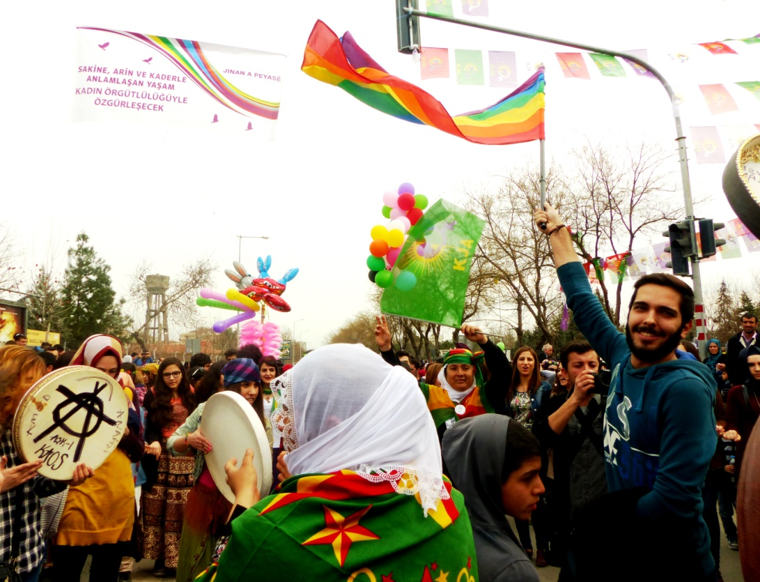
8th March International Women's Day in Amed (Diyarbakir) (Photo credit: Dilar Dirik)

NOTES
Öcalan, Abdullah, 2010, Jenseits von Staat, Macht und Gewalt (Cologne: Mesopotamien Verlag).

Öcalan, Abdullah, 2011, Democratic Confederalism (Cologne: International Initiative "Freedom for Abdullah Öcalan - Peace in Kurdistan),
Available online at http://www.freeocalan.org/wp-content/uploads/2012/09/Ocalan-Democratic-Confederalism.pdf

Öcalan, Abdullah, 2013, Liberating Life: Woman’s Revolution(Cologne: International Initiative "Freedom for Abdullah Öcalan - Peace in Kurdistan), Available online at http://www.freeocalan.org/wp-content/uploads/2014/06/liberating-Lifefinal.pdf

(Öcalan, 2011, p.17)
(Öcalan, 2010, p.267)
(Öcalan, 2013, p.53)

