Qelam cultural website interview with
freelance journalist and author
Azad Karimi
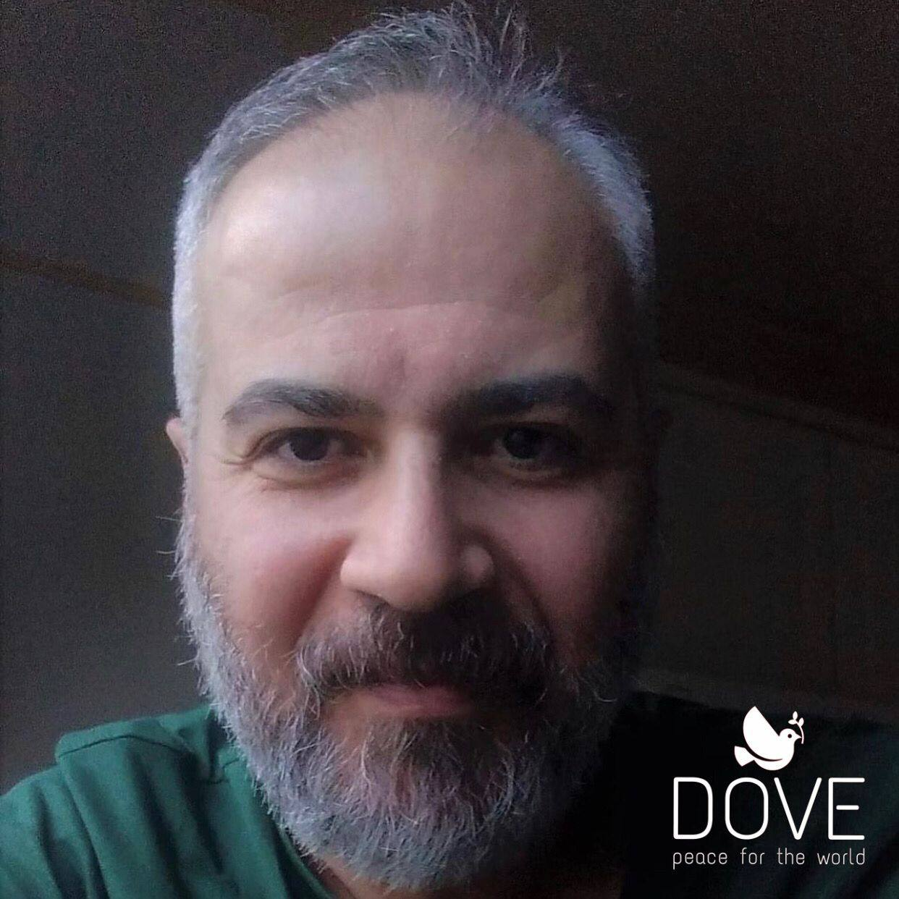

The original of this interview was published two years ago in Kurdish.

- During this time you conducted a large project that is continuing, which was conversations in English with many people around the world, from writers, musicians, philosophers, painters, etc., which are constantly downloaded on the website. How did you come up with the idea for this project?
-Hello and welcome! I tried this type of writing dialogue in 2004 and 2005 in Saqez and the results were unique and successful. I got a lot of old photos and writings and made many of them into articles they were published in newspapers and websites and they are still being copied and published here and there. I even gave some of them to the famous French journalist Chris Kutschera and he published them on their valuable website, Kurdistan Photo Library, which I am proud of.
The spark of this project came to me the day before International Yoga Day while chatting with Yogi Acharya from Nepal. I kept asking questions about yoga and he answered them. Then I said please let me discuss it and let me publish it tomorrow! He liked it very much. I released it and this time I talked to a guy who played Handpan in Switzerland, I didn’t know anything about Handpan. He permitted me to publish this dialogue as an interview. After that a conversation with an Argentinian painter and he let me publish… that’s the story.
I thought it would be good to write some questions like that year in Saqiz and give them to people with talent and proper speech. Otherwise, many people are talking these days and they may have many listeners, but their words do not go a unit palm in front of their mouth. The truth is that I don't like talking too much and on the contrary, I love pragmatic and capable people. Fortunately, my project has received an unprecedented response, and this month it is nearly two hundred people responded to me and I should write an introduction to them and publish them.

- What is the aim of this project?
-There is an idea of Humanitarian International behind this project. I studied international law, which is a very important subject in the field of rights, at university. In 1945, after World War II, the states decided to create the United Nations. But the most appropriate title for this organization in my opinion is The United Countries or The United Independent States because many nations in the world do not have an independent state, such as the Kurds, American Indians, Amazighs, and many other nations. Now it's not about the absence of a state and these issues about these kinds of people in the world, I thought to let them come out and be exposed and obviously, there are no such views in the world to name this kind of thing and swallow you. Yesterday, the Turkish Foreign Minister said that we raised the Kurdistan flag to prove that our problem is not a problem of Kurdish identity... They confirmed this in practice... This month, the Erzurum and Wan courts ruled that raising the Kurdistan flag is not illegal . . . . These're all symbols.
A lot of things have changed. In Iran, until 1979, boys were forbidden to wear Kurdish clothes in schools. Until recently, only one province was known as Kurdistan: Sna, Saqiz, Baana, Mariwan, Garus, Qurwa, and Kamyarān.
We not to mention Kermanshah, Urmia, Ilam, Mahabad, Bokan, Shabad, Salmas, Dinawar, Kangawar, Sahna, Hawraamaan, Maku, and thousands of villages in East Kurdistan that do not belong to Sna province and exist from the Aras River to the border of Mehran and Diyala. Now the word *Kurdistan of Iran* is being talked about in Iranian(governmental and non-government) media.
No one in the world can deny this. If there is, it is not official even if they have hundreds and tens of thousands of listeners and followers.
Even my reading of the Kurdish cause has changed and if it is not what I claim, I still don't understand what's going on in the world. In this project, which I have called “My Utopia,” with the help of my ideational background, journalistic experience, feelings, and desires I have started this cultural project to do something humane and unprecedented and to benefit myself, the people of Kurdistan, the Middle East, Asia in general, the beloved Europe where I live, the United States, Australia, New Zealand, and Africa.
In this cultural world of mine, wolves and sheep drink together from a water source. It's great... it's great... I've been supported by people close to me in Norway, my Norwegian compatriots, and many people outside Norway. I'm sure the states support this and will be. Because this is how the world feels about itself. Have you seen how Kosovo and Serbia reconciled? How did they all turn to Israel? Do you know how Israel and the UAE reconciled?
So how can the Kurdish problem, which is an internal problem of several states and also an international problem, not is resolved?
Let the Kurds show their mental will and try to pave the way for the solution of the problem, also as an outsider side look at the Kurdish issue. If you do, you will avoid tension and violence. Kurdish people are no more valuable blood than the rest people of the world.
Let us not be like Mullah Nasrudin. He fell into a pit and people gathered and shouted, “Mullah! Give us your hand and let us pull you out of this pit! Mullah Nasrudin had his mouth closed and his hand in his robe pocket and was doing nothing. Finally, a wise man appeared and said I know how it comes out... he shouted, Mullah! I'll reach out, hold my hand and let me get you out! Mullah Nasrudin took the man's hand and came out with a jump.
The people were shocked! The man said, “Don't forget! You don't know what the mullah is like yet! When does the mullah have a giving hand? ...The mullah always has the holding hand!
I said this, let me tell you that I hate to show off being poor so that people will have mercy on me... Oh, I was a lion, but I became poor and miserable!
The world is not a place for the Miserables. If you are miserable, sit back and don't create problems for yourself and others. If you consider yourself a victim, so speak wisely and proudly... I think so...
Therefore, in my utopia, everyone is a Kurd to me... That is why I like everyone's words and everyone is beautiful and cute to me in this project If he-she is a Turk in Malkani and Mianduaw or an Italian singer or a unique Broadway actor in New York. Whoever wants to come, welcome! , but be talented.
My utopia is a pattern of God's great world, but everyone is free to say: I think, therefore I am (Cogito ergo sum)... as Rene Descartes wrote 383 years ago in Discourse on Method. If you think more you talk less and try harder. Explaining the principles is chattiness and useless. So let me do something for a "proper job"... As much as they call us brave, let them know us as cautious. Courage and caution certainly build trust in the other person.
Trust brings respect, and respect brings love, friendship, brotherhood, fellowship, and sharing. It will that you may share the bread on your table with the other person without thinking about it... and you will think so normal that you don't consider giving bread to people as charity and it will be like breathing... Therefore, no one can say that breathing for life is an etic act and will take you to heaven and give you the virgin nymphs and sexy guys!
You must eat your bread with people and not consider it a Good and Religious rule... Like breathing, it must be part of your human essence. I think so. I'm so happy to think so.

- How were your making communications? Did they welcome you with open arms?
-I would send messages on Facebook Messenger and they would answer me sometimes it would become an in-depth conversation and then I would reveal the story and they would say well we are with you. I've only seen two or three people say strange things. But yesterday, on average, the staff of a French film answered me! They even sent me the initial announcement of the film even though no one has seen it yet! I have understood that I have to do this and it's not for fame and other things... The first mental motivation is a conscience and a sense of responsibility.

- What are your feelings and opinions after all these discussions, which have been more than a hundred?
-I feel so good... I grew up so much... So many men and women are my friends... They often make me cry. I'm really surprised at the greatness of these people! So I love this world as much as I ever loved my mother's arms when I was a child. They are all flowers in the garden... gold, gems.

-As a Kurdish writer, what aspects of these discussions were interesting to you?
-I'm not saying I'm mentally changed, because I had enough in it to fit into Western life and I don't have a problem with it. I learned a lot here about social behavior, communication, and understanding.
So much so that I don't feel alienated. I don't consider myself a foreigner... I don't remember being considered a foreigner. Nobody feels that I have been living in Europe for five years and I am new... The conversations with me are like people from Britain, Italy, Spain, Portugal, France, Belgium, the Netherlands, the United States, Serbia, Bosnia, Kosovo, Croatia, Austria Poland, Australia, Latin America, Malaysia, China, Japan, Malaysia, India and Afghanistan, Pakistan and Africa. Scandinavia is like my home, Denmark and Sweden, which will become Norway or Israel, Arab countries, Turkey, Armenia, and Georgia, which will become Kurdistan and Iran No one has ever been an enemy of Kurdistan or Iran... Nice! it's beautiful! It is a world full of friendship.

-Do you want to publish these conversations as a book in the future? Do you have a translation program?
-Yes... Let me talk about the Qelam website and the dear administrators and Mr. Farokh who supported me and opened the English section to publish these cultural discussions on the Qelam website. Now the beloved Qalam has started publishing it and as we can see, a significant number of people are constantly reading these interviews.
This is an unprecedented work. It must be done... Now it's up to me to do it, no problem I'll do it and I'll try with all my heart and soul. I don't have time to translate... Because the coronavirus has emerged and I'm at home, I can do this. When work and life return to normal in the next few months, I will move to a normal running-up lifestyle. So I'm going to finish this project and go to the publishing. I talked to my manager-advisor in the Norwegian system, a lovely lady, about it and she told me what I should do.
Mr. Farokh Nematpour, a famous Kurdish author, is very sensitively aware of the situation and we have drawn up a program for it.

- The last words...?
-Interestingly, we have found that reading in English has increased significantly both in Kurdistan and around the world, and this is a big step for the people of Kurdistan and the world to feel more connected. congratulations! They said to the blind man: What do you want? He said: Two seeing eyes to see!! We wanted to come out behind the walls and talk to people. Talking about happiness and friendship. Thank God and thank my country Norway, I don't have any household problems. But my problem here is help... There must be people to organize my articles. That is the editing of mistakes. I can just write the introductions for the interviews. It's piled up and I'm sad... My problem is time.
The interviewers ask me to publish their conversations early. Do they know I'm about to collapse under their answers? I thank many great people in the world for their support and that makes me happy to try harder for this humanitarian project. Thank you for your beautiful website for hosting my articles... I love you.

Be Happy!
https://www.qelam.com/index.php?option=com_content&view=article&id=3527:qelam-interview-with-azad&catid=95&Itemid=527

